Objectives

- Use the CLI interface on both Packet Tracer and a physical switch
- Familiarize yourself with the user interface
- NOTE: If you enter text in PT that is not a command you will get a “searching” message and
go into wait state. Hit CTL-SHIFT-6 to exit!
- Create a word DOC file – LAB2A-yourlastname.DOCX
- Format the headers per the SUBMISSION GUIDELINES in our iLearn resources
- Include the following sections in your lab submission
  - Purpose - In your own words, what is the purpose of this lab?
  - Questions – What the are answers to any questions asked in the lab?
  - Screenshots – Include any screenshots
  - New Terms/Commands – What new CLI commands or networking terms were introduced?
  - Comments/Reflection
- Launch Packet Tracer on your workstation.
- Add a NOTE with your name, class id and the text “LAB2A CISCO CLI”

A - Use Packet Tracer to explore the CLI modes for a switch

- Drag and drop a 2960 switch to the work area.
- Add a console PC and connect it to the switch via a CONSOLE cable. Enter TERMINAL mode to access the Command Line Interface.

- Click on the switch, then click on the CLI tab, and allow the switch to load.

- You are now in EXEC mode (Switch>). Enter "?" to see what commands are available in this mode. Make sure you
Q1 – How many commands are available in EXEC mode?
- The SHOW command is an often used command. It is used to display various information a bout the switch. To see what information you can display, enter "show ?"
- Enter the command “SHOW MAC-ADDRESS-TABLE”
- Enter the text “SHOW MAC-” and hit the TAB key. This will fill in the entire command for you.
- Whenever you see “--MORE--" you can hit ESC, SPACE or <ENTER>. Enter the command “SHOW INTERFACES” and see what each of the three keys does.

Q2 – What is the difference between hitting SPACE and hitting <ENTER>?

- Enter "show version"

Q3 – What is the Base Ethernet MAC Address of the switch?

- To enter Privileged Mode enter "enable". Note how the prompt has changed!
- Enter "Disable" to return to EXEC mode.
- Enter "Enable" to return to Privileged Mode
- Enter "?" to see the Privileged commands.
- Enter “SHOW HISTORY”.

Q4 – What does SHOW HISTORY do?

- To enter Global Config Mode enter "conf t". Note how the prompt has changed again.
- Enter "?" to display the list of commands now available.
- To change the name of the device (switch) enter "hostname xxxxxx" where xxxxx is the desired name.
- Change the name of the switch to yourlastname.
- Note the change in the prompt!

- A 'message of the day' is used to display a message whenever the switch is accessed. Enter "banner motd # a message of your choice #" - the has tags are start/end delimiters
- Hit CTL/Z to exit mode, then enter "show running-config"
- What information do you get from the SHOW RUNNING-CONFIG command?
- You can enter the command RELOAD to reboot the switch. After the “HIT RETURN…” prompt you will see your message of the day
- Press CTL-P <or> the UP arrow a few times - this will display some previously entered commands.
- Let's password protect privileged mode! Enter the following to set the password to "marist":
  - configure terminal
  - enable password marist
  - exit
- Now show the running configuration again.

Q5. What information in the configuration shows that the password protection worked?

- Enter "exit" again to return return to Exec Mode.
- Enter “enable” – you should now be prompted for a password.

B - Use Packet Tracer to explore the CLI modes for a router

- Now drag and drop a Router to the packet tracer workspace.
- Click on the router, and then the CLI tab.
- Note that - unlike a switch - there is some automatic setup prompts for a router.
"Would you like to enter the initial configuration dialog? [yes/no]:"
If you enter "yes" it will guide you through some default setup prompts.
But we are going to enter "no".
- By entering "no" we are put into the user EXEC mode, just like we did for a switch.
- Using the commands learned in Part A, change the name of the router.
- Note how the prompt has changed.
- Now enter "no hostname."
Q6. What do you think the “NO” command does?
- You can use the "no" prefix for some other commands ("no shutdown", "no zone", etc.).
- To enter Privileged Mode enter "enable".
- Return to EXEC mode, then close the Router's CLI box.
C - Use Packet Tracer for further exploration

- Drag and drop a Switch, and 2 PC’s to the packet tracer workspace. Connect the PC’s to the switch.
- Delete the switch – this should also delete the two connectors.
- Drag a REPEATER to where the switch was, and connect the first PC.
- Try to connect the second PC. What happens? Click on the physical tab – how many ports are there?
- Delete REPEATER.
- Add 4 more PC’s.
- Drag a HUB to where the switch was, and connect all of the PC’s.
- Now add another (a 7th) PC, and connect it. Do whatever is required to accomplish this.

Note: Make a screenshot of your current Packet Tracer screen and include it your lab submission
file. Complete sections d and e, and submit in iLearn.

** Class Note: Return to Powerpoint ***

D - Use PuTTY to explore the CLI modes for a switch

- Connect your physical switch to your workstation using a serial to RJ-45 cable. Connect the RJ-45 into the switch's console port.
- On WINDOWS open the DEVICE MANAGER Or run the command devbmgmt.msc.
- Find the PORTS tab. Open the tab to determine which COM port is used.
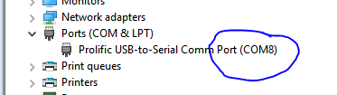
- Launch PuTTY on your workstation.
- On the configuration screen, select the SERIAL button, and enter the COM port from above. Then click on OPEN.
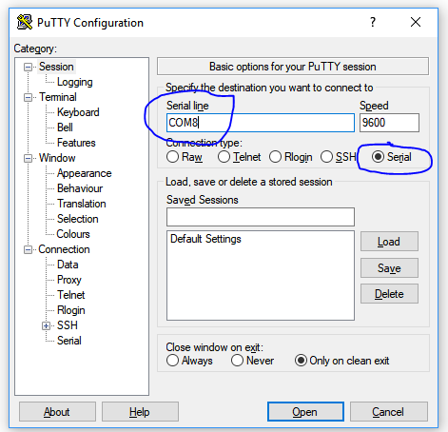
- Turn on the switch! You may have to wait and/or hit ENTER, but you will see the switch's boot messages displayed.
- Once the switch is ready, follow the same steps in Part A of this lab. (You do not need to record the question answers.)
- Use the SHOW INTERFACES command to determines the MAC addresses of each port.
- Once your finish, feel free to experiment with some other commands.
- IMPORTANT: When complete, in Enable Mode enter RELOAD to refresh the switch back to it’s initial state
- NOTE: If you a prompt like “switch:” the switch is in boot mode and needs to be Reset. Type “BOOT”.

E – How to reboot a switch

- Via PuTTY enter the command RELOAD. Watch the display.

